RABBIT PVT. LTD.
MINOR PROJECT ASSESSMENT
Network Discovery, Information Gathering, Enumeration and FTP Security Testing

Student Name: Kovuri Hemalatha
Batch / Team: July 2026 (Cyber Security)
Date: 29 September 2026
Target: scanme.nmap.org
Target IPv4: 45.33.32.156
Target & scope
The assessment was conducted against the authorized Nmap test host scanme.nmap.org. The hostname resolved to the IPv4 address 45.33.32.156 during the assessment.
The scope of this assessment is limited to network discovery, TCP port scanning, service identification, service enumeration, and other non-destructive security checks permitted for the selected training target.
No credentials, personal information, or unnecessary sensitive information are included in this report.
The target and authorization basis will be supported by the Shodan evidence and the documented purpose of the Nmap test host.
Shodan Target Discovery Evidence
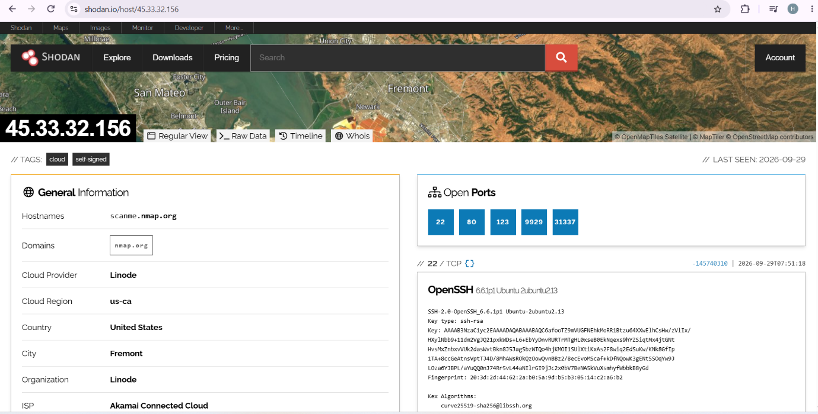
Methodology
The assessment followed a structured reconnaissance and enumeration workflow.
- Identify and document an authorized training target.
- Resolve the target hostname to its current IP address.
- Perform an initial Nmap TCP scan to identify commonly exposed services.
- Perform a full TCP port scan where appropriate.
- Identify service names and versions on discovered ports.
- Build an attack-surface table from the scan results.
- Select important services for further enumeration.
- Investigate FTP if it is exposed; otherwise assess another relevant service.
- Document security observations using controlled, non-destructive validation.
- Record evidence, impact, remediation, and conclusions.
Nmap Scanning → Initial Nmap Scan
DNS Resolution
Command:
nslookup scanme.nmap.org
Result:
45.33.32.156
📸 DNS screenshot here.

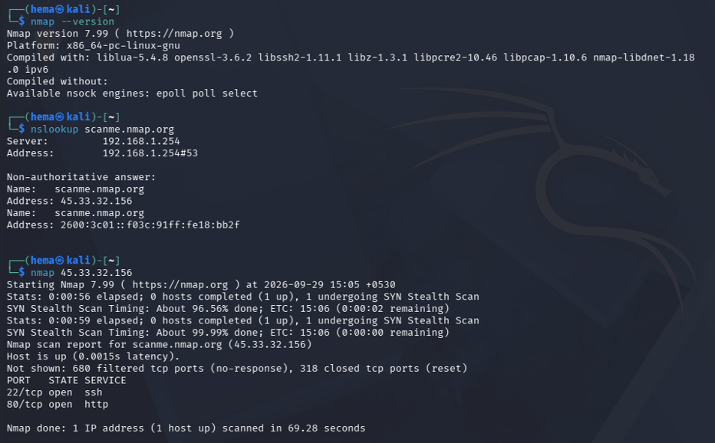
Initial Nmap Scan
Command:
nmap 45.33.32.156
📸 Insert basic Nmap screenshot here.
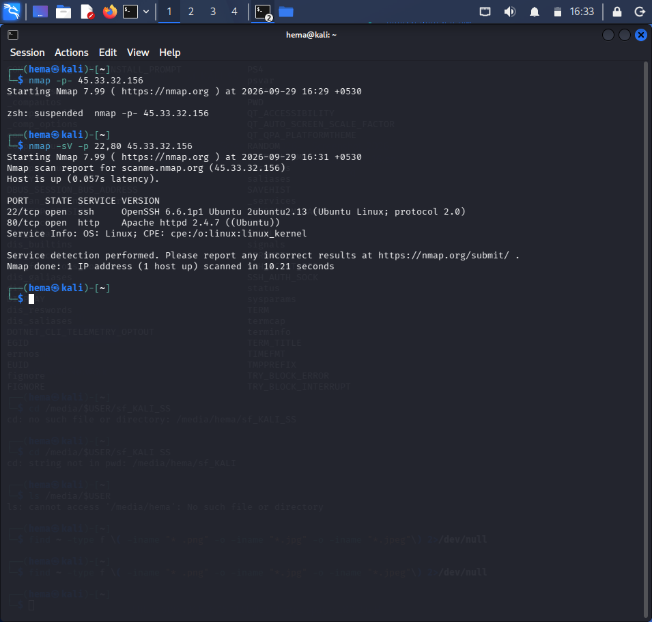
Operating System Identification
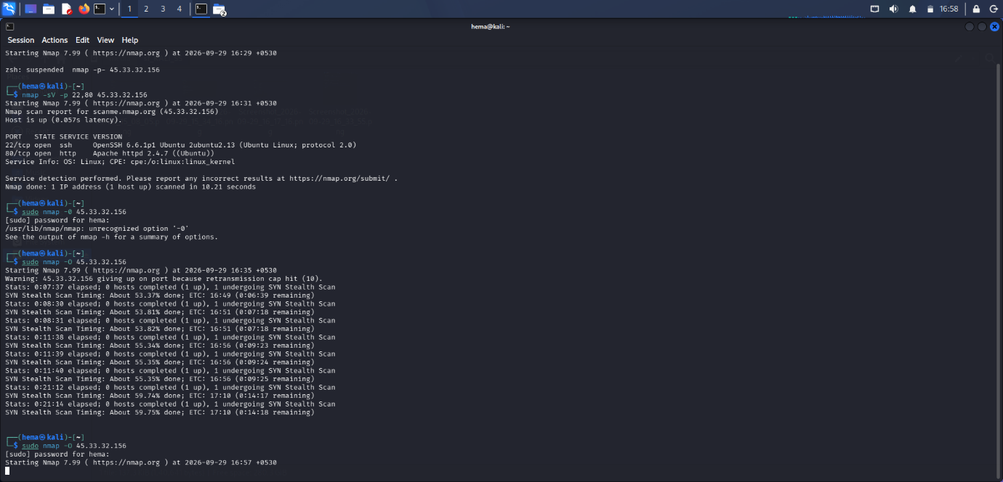

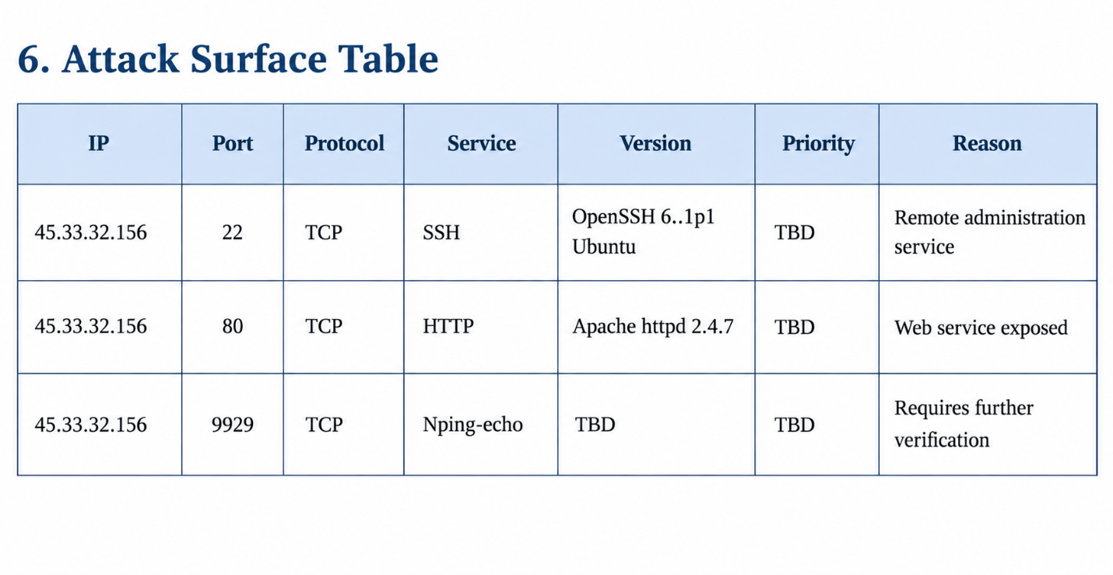
HTTP Enumeration
Command:
curl -I http://45.33.32.156
Purpose:
The HTTP headers were inspected to identify the web server response and additional information exposed by the HTTP service.
Result:
Paste your actual output here.
📸 Screenshot:
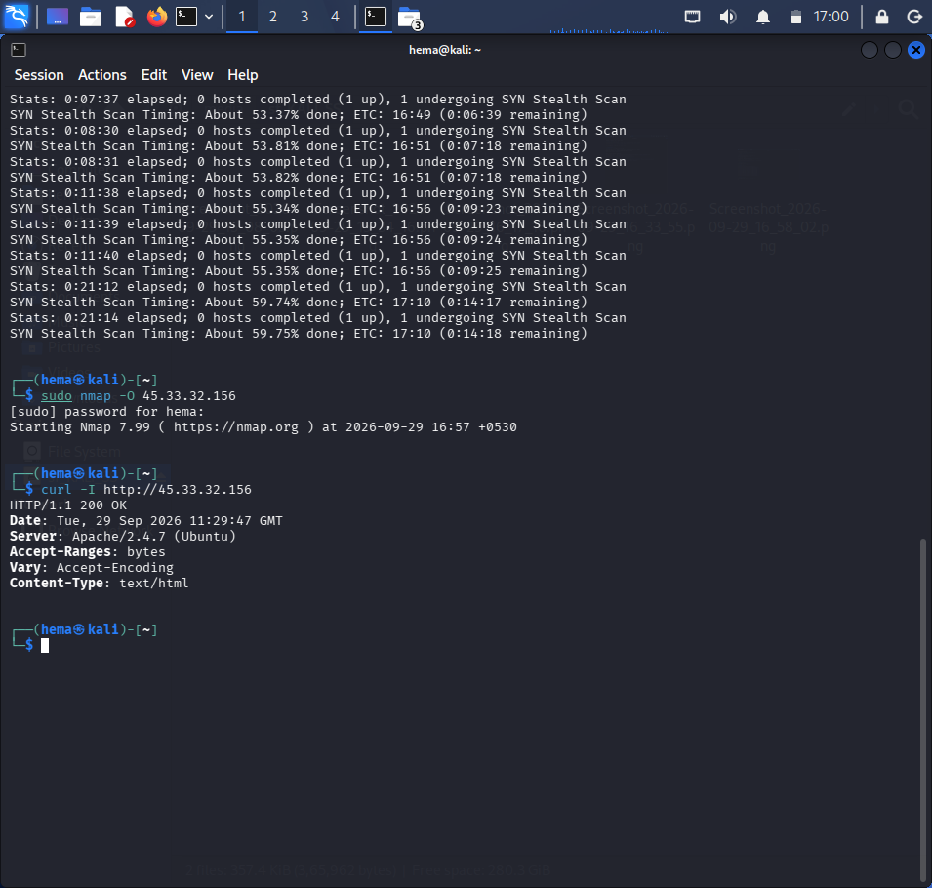
SSH Enumeration
Purpose:
The SSH service was enumerated to confirm the exposed service and collect its publicly available banner information without attempting authentication.
Command:
nmap -sV -p 22 --script=banner 45.33.32.156
Result:
Paste your actual output.
Screenshot:
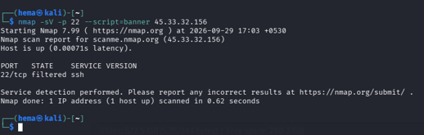
Unknown Service Investigation
Port: 9929/tcp
Initial identification: nping-echo
Command:
nmap -sV -p 9929 45.33.32.156
Result:
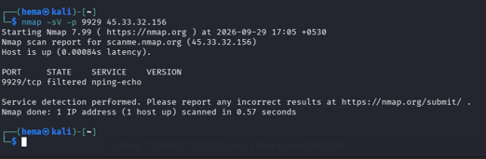
FTP Availability Check
Command:
nmap -p 21 -sV 45.33.32.156
Interpretation:
If port 21 is closed/filtered, we'll state that FTP was not exposed and proceed with the HTTP service as the alternative assessment.
📸 Screenshot:
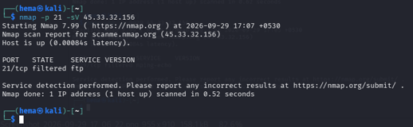

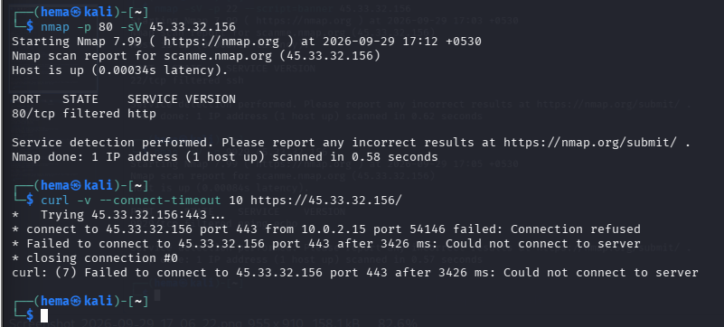
FINAL MINI ASSESSMENT

1. Target Selection and Scope
The selected target for the assessment was the authorized Nmap training host scanme.nmap.org, which resolved to IPv4 address 45.33.32.156.
The assessment was limited to network discovery, port scanning, service identification, enumeration, and controlled non-destructive security testing of the selected target.
2. Host and Port Discovery
DNS resolution was performed using nslookup to identify the target IP address.
The initial Nmap scan identified externally accessible services including:
- TCP/22 — SSH
- TCP/80 — HTTP
- TCP/9929 — Nping-echo
A full TCP scan was subsequently performed to check the complete TCP port range.
3. Service and Version Identification
Service/version detection identified the following services:
Port | Service | Version
22/tcp | SSH | OpenSSH 6.6.1p1 Ubuntu
80/tcp | HTTP | Apache httpd 2.4.7
The service information was used to determine which services required additional enumeration.
4. Detailed Enumeration
The discovered services were investigated using appropriate protocol-aware tools and Nmap service detection.
HTTP was investigated using HTTP requests, while SSH and the service on port 9929 were investigated using Nmap-based service identification.
5. FTP Investigation
TCP port 21 was checked to determine whether FTP was exposed.
If FTP was not exposed, HTTP was selected as the alternative service for the assessment.
6. Security Observation
The assessment identified the following security-relevant observation:
The observation was evaluated using non-destructive validation. No unauthorized access or destructive activity was performed.
7. Impact
The potential impact of the identified observation depends on the affected service and the confirmed technical evidence.
8. Remediation
Recommended remediation should address the confirmed security observation. Depending on the final finding, this may include updating outdated software, restricting unnecessary network exposure, strengthening service configuration, or applying appropriate access controls.
9. Conclusion
- The assessment successfully demonstrated the complete network reconnaissance and enumeration workflow.
- The target hostname was resolved to the identified IPv4 address.
- Nmap was used to discover open TCP ports and identify exposed services.
- Service/version detection identified SSH and HTTP services running on the target.
- Additional enumeration was performed on the discovered services using appropriate tools.
- FTP availability was checked, and an alternative service was considered where applicable.
- All testing was performed using non-destructive techniques within the defined assessment scope.
- The collected commands, outputs, and screenshots provide evidence supporting the assessment results.

